CSIT314 Software Development Methodologies - Group Project

Sprint 3 - US30: Customer log in
Interior Design Platform - Customer
All diagrams were drawn in draw.io. Open "US30 Customer log in.drawio" in this folder to edit them - each diagram is its own page in that file. The exported images are in the "diagrams" folder.

Assumptions
- The system is the Interior Design Platform from the project specification. Sprint 3 covers the Interior Designer's current IDP stories (US20 - US24) and the Customer's log in, search IDPs, view IDP and log out stories (US30 - US32, US36).
- A Customer is a user account whose user profile is Active and has the "Search, view and save IDPs" permission (REQUIRED_CUSTOMER_PERMISSIONS). We check the permission, not the profile name, so a renamed customer profile with that permission can also log in.
- We follow B-C-E: the actor only talks to the boundary (page), the boundary only talks to the controller, and the controller works with the entity classes. There is one controller per use case.
- Who checks what: the page checks that both fields are filled in and trims the spaces from the username (not the password). CustomerLoginController.login() makes one call: UserAccount().verifyCredentials(username, password, REQUIRED_CUSTOMER_PERMISSIONS) - it doesn't check the input again. verifyCredentials() does every database check in one call: the password hash, the account status, the profile status and the permission. Checking the role is allowed here because logging in is the use case itself.
- The customer's user account is made by the User Admin first (UC8). US30 reuses the existing UserAccount entity class (it reads the account's user_profile row itself), so no new table is needed.
- Customers log in on their own page (/customer/login). The shared /login page (US1) is for User Admins only, so a customer gets the US1 error message there.
- Every failed login shows the same message ("Invalid login details or access unavailable"), so the page doesn't tell anyone whether the username exists or the account is suspended.
- When the login works, the old session is cleared and only userId, profileId and username are saved. The password is never saved in the session.
- The customer dashboard just renders - it doesn't check the account or profile again. customerLoginRequired in app.py only sends someone with no session to /customer/login. Logging out is its own use case (US36) with its own controller.
- The story says "view and manage my saved IDPs": in this project managing means saving an IDP (US33) and viewing or searching the saved list (US34, US35). There is no remove (unsave) feature.

1. User story
Story ID | US30
User story | As a customer, I want to log in so that I can view and manage my saved IDPs.
Actor | Customer
Priority | High
Story points (estimate) | 3
Acceptance criteria | 1. Given I open the customer login page, then I see a username and password form (the password is hidden).  2. Given my username and password are correct, my account and profile are Active and my profile has "Search, view and save IDPs", when I click "Log in", then I go to the customer dashboard and see "Welcome back, <username>".  3. Given I leave the username or password empty, then I see "Please enter your username and password".  4. Given the password is wrong, the username doesn't exist, my account or profile is suspended, or my account is not a customer, then I see "Invalid login details or access unavailable" and I am not logged in.  5. Spaces around the username are ignored; the password is used exactly as typed.  6. Given I am not logged in, when I open the customer dashboard, then I am sent to the customer login page.
Tasks | #144 Develop customer login and authentication logic  #153 Draw Use Case Diagram and Description  #164 Draw BCE and Sequence Diagram  #173 Design Wireframe  #183 Write and Execute Test Cases

2. Use case diagram
The user story becomes one use case, UC30 Customer log in. The Customer is the only actor.
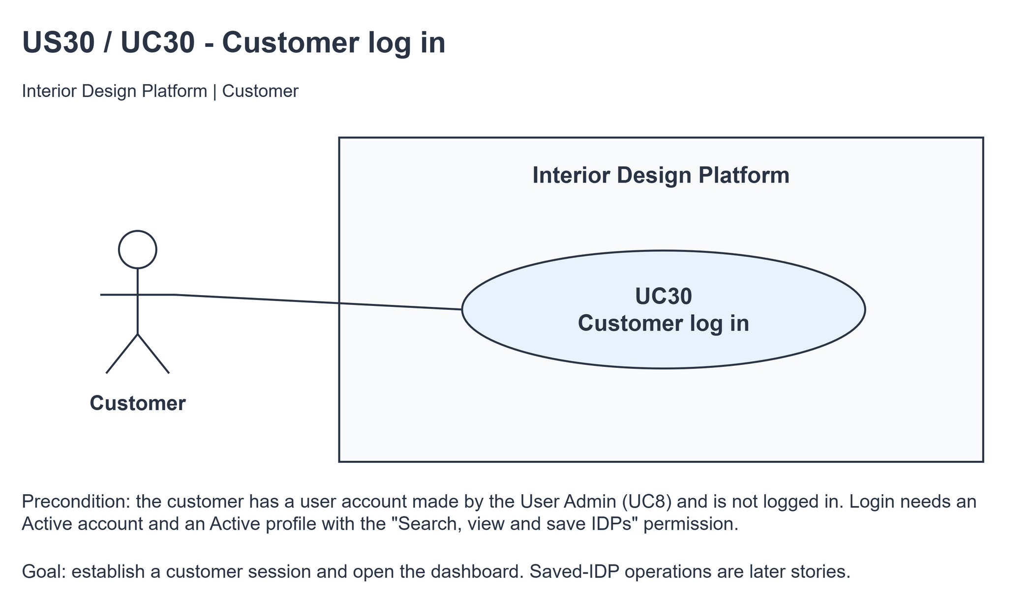
Figure 1: Use case diagram for US30 Customer log in

3. Use case description
Use case | UC30 Customer log in
Actor | Customer
Brief description | The Customer logs in with their username and password so they can use the customer dashboard to search, view and save IDPs.
User story | US30: As a customer, I want to log in so that I can view and manage my saved IDPs.
Preconditions | The customer has a user account made by the User Admin (UC8) whose user profile has the "Search, view and save IDPs" permission.  The Customer is not logged in.
Trigger | The Customer opens the customer login page.
Basic flow | 1. The Customer opens the customer login page.  2. The system shows the login form.  3. The Customer types their username and password and clicks "Log in".  4. The system checks that both fields are filled in and trims the spaces from the username.  5. The system checks the username and password, that the account and its user profile are Active and that the profile has the "Search, view and save IDPs" permission.  6. The system starts a new session and opens the customer dashboard.  7. The system shows "Welcome back, <username>".
Alternative flows | 4a. A field is empty: the system shows "Please enter your username and password". Back to step 3.  5a. The username or password is wrong, the account or profile is suspended, or the profile doesn't have the customer permission: the system shows the same message "Invalid login details or access unavailable". Back to step 3.
Postconditions | The Customer is logged in. The session holds userId, profileId and username.  The customer dashboard is shown.

4. Wireframes
The wireframes were drawn in draw.io. They are low-fidelity: they show the layout and the flow, not the final colours. They follow customerLogin.html, customerBase.html, customerDashboard.html and static/style.css.

4a - Customer login form
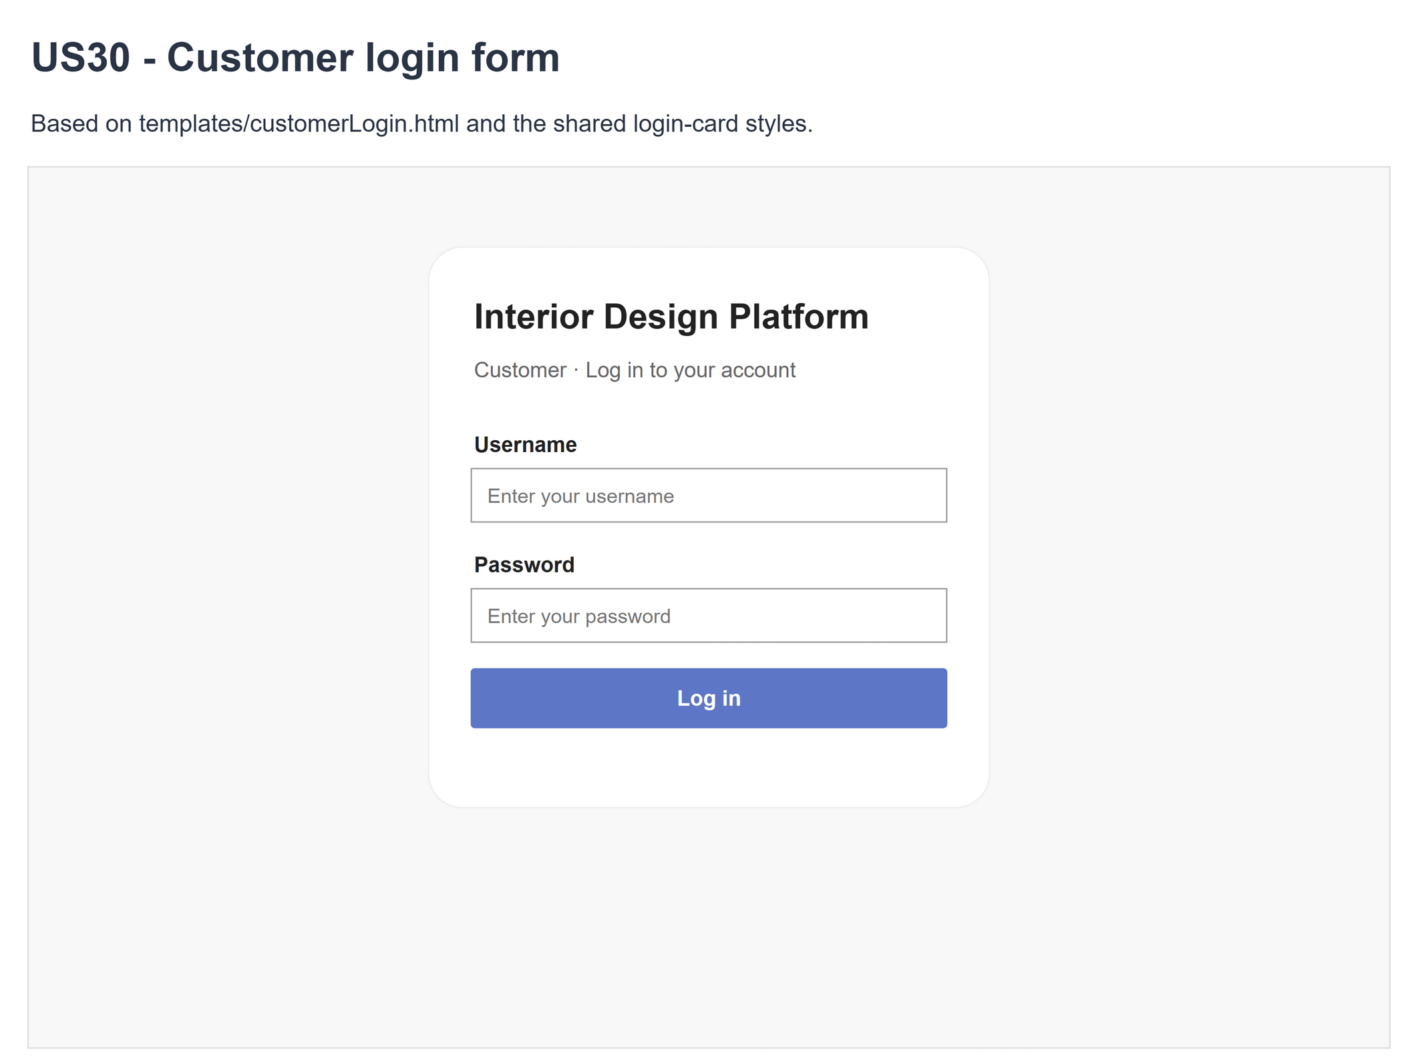
Figure 2: Wireframe 4a - Customer login (US30)

4b - Customer dashboard after login
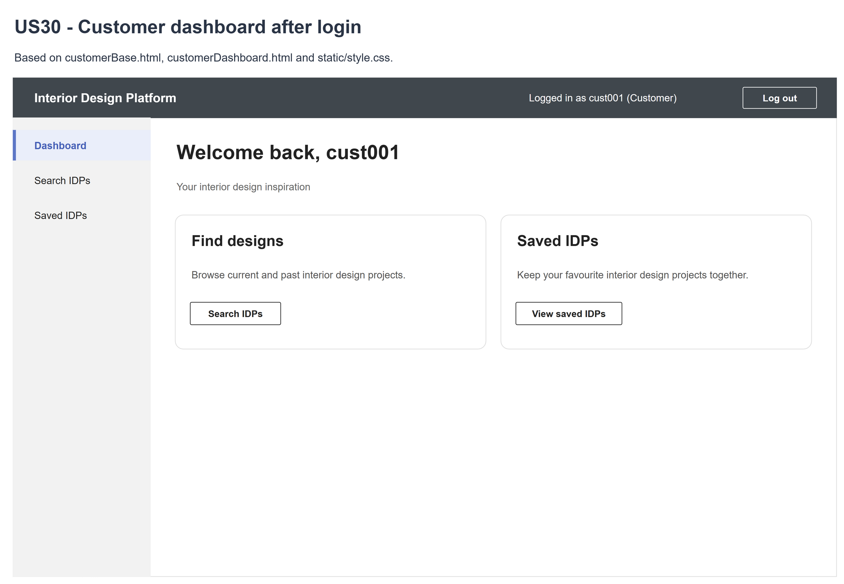
Figure 3: Wireframe 4b - Customer dashboard (US30)

4c - Invalid credentials or unavailable access
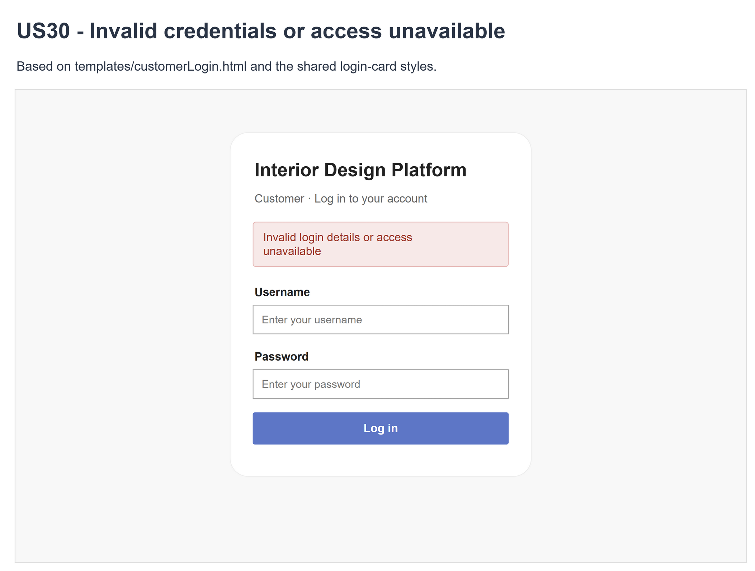
Figure 4: Wireframe 4c - Invalid login (US30)

4d - Missing required fields
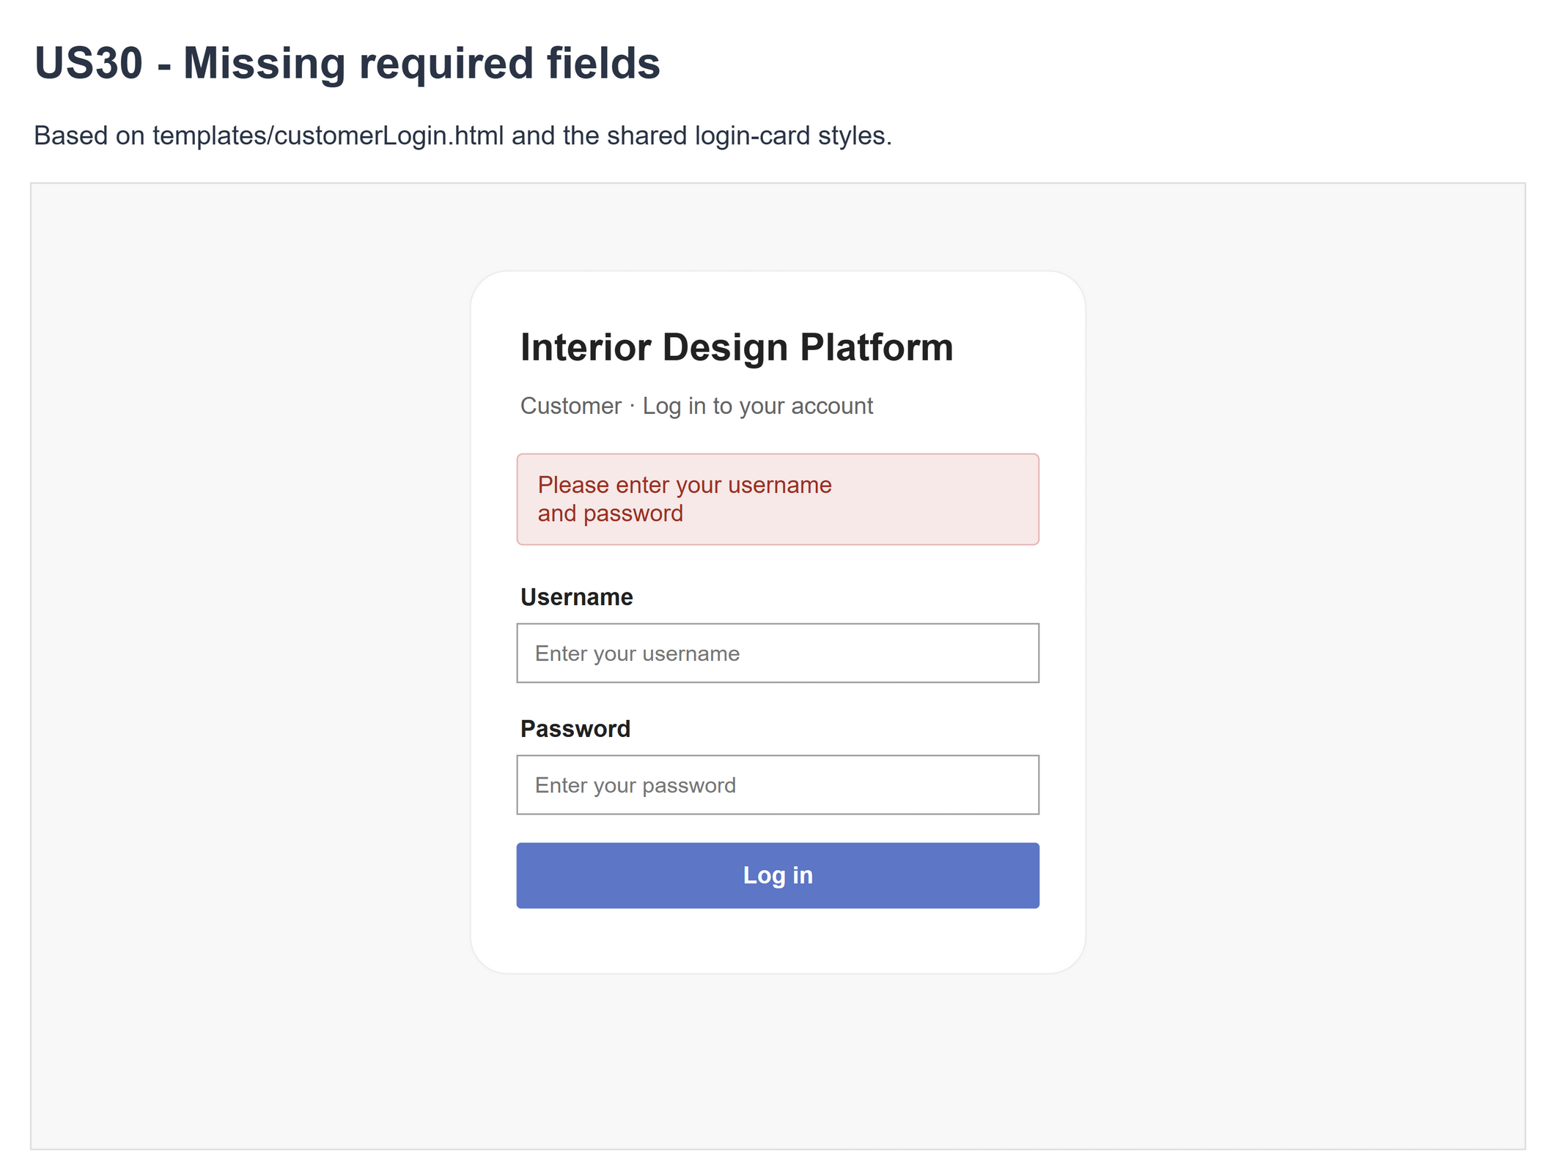
Figure 5: Wireframe 4d - Missing fields (US30)

5. B-C-E class diagram
The solid line means the boundary calls the controller. The dashed line means the controller uses the entity class. Only the operations needed for this use case are shown, with the same names as the code.
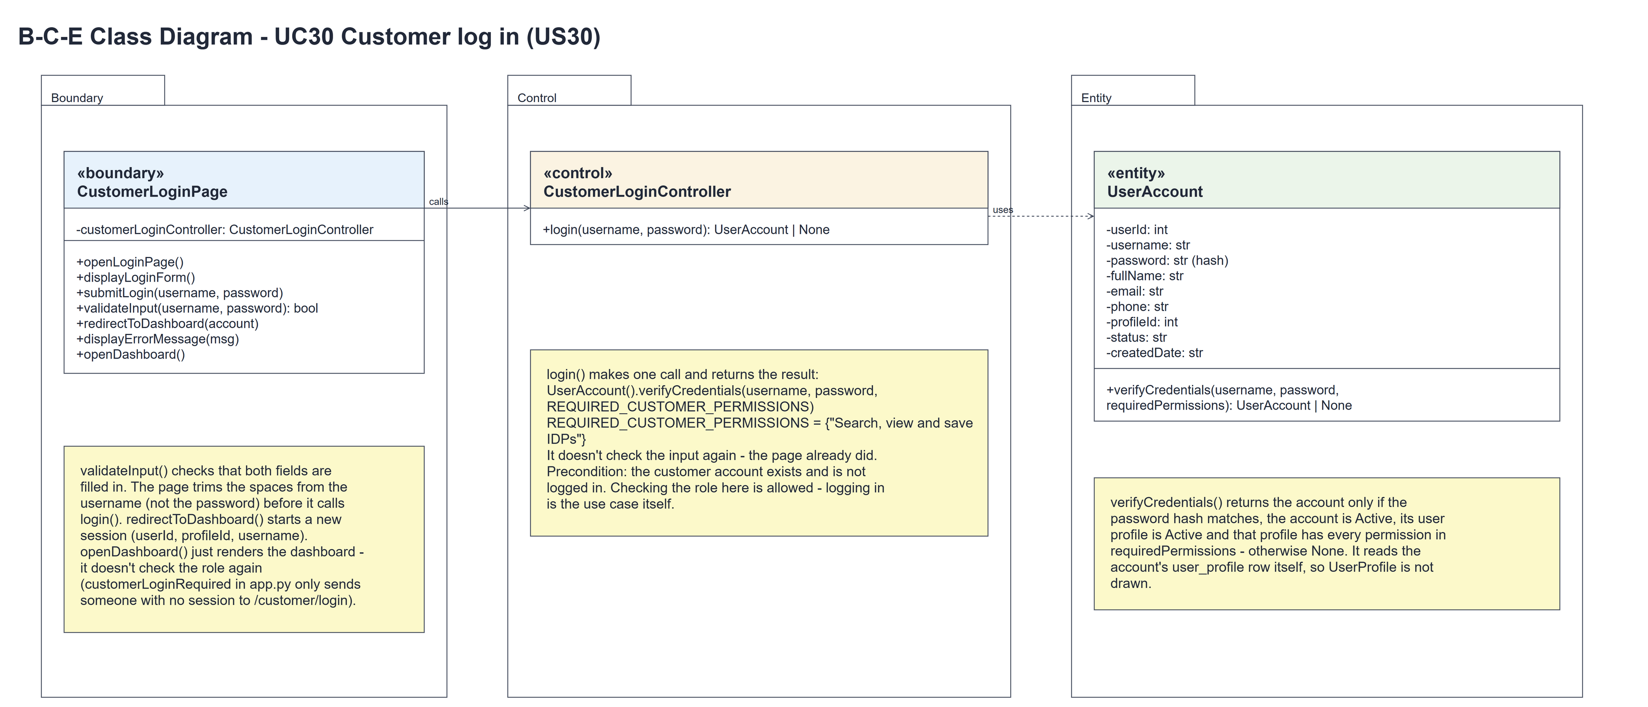
Figure 6: B-C-E class diagram for US30 Customer log in
Layer | Class | What it does
Boundary | CustomerLoginPage | The customer login page and dashboard. validateInput() checks both fields are filled in, submitLogin() trims the username and calls login(), redirectToDashboard() starts the session and displayErrorMessage() shows the messages (MSG_EMPTY_FIELDS, MSG_INVALID_LOGIN). openDashboard() just renders the dashboard - it doesn't check the role again.
Control | CustomerLoginController | Controller for UC30. login() just calls UserAccount.verifyCredentials(username, password, REQUIRED_CUSTOMER_PERMISSIONS) and returns the account or None.
Entity | UserAccount | The existing user account (US1). verifyCredentials() returns the account only if the password hash matches, the account is Active, its user profile is Active and the profile has every required permission. It reads the profile row itself.

6. Sequence diagram
The sequence diagram follows UC30. The page shows the form (steps 1-3) and checks the input when it is submitted (step 5). The outer alt covers alternative flow 4a: an empty field is caught by the page. For filled-in input the page trims the username and calls login(), which makes one call to UserAccount.verifyCredentials() with the customer permission (step 8). The inner alt shows the two endings: the session is started and the customer dashboard opens - openDashboard() just renders it - or the same error message for every kind of failure (alternative flow 5a).
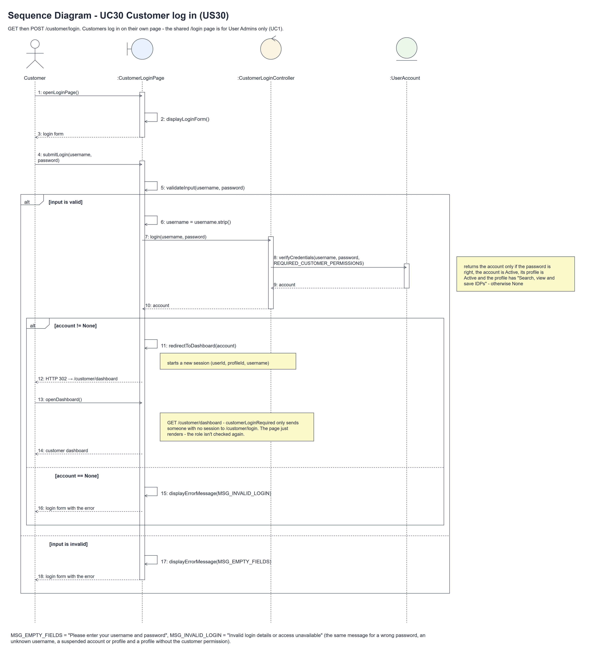
Figure 7: Sequence diagram for UC30 Customer log in

7. Test cases
Test data used below (same as database/seedData.py and the test file): user profiles User Admin (id 1), Interior Designer (id 2), Customer (id 3) and Platform Manager (id 4), all Active. User accounts admin01 / Admin@123 (User Admin) and cust001 / Cust@123 (Customer). Some tests suspend the account or profile, remove the permission or use designer and manager accounts. Tests use an isolated database.

7a. System test cases (black box)
Equivalence partitioning and boundary value analysis were used to pick the test data. Fill in "Actual result" and "Pass/Fail" after running each test.
Test ID | Scenario | Prerequisites | Test steps | Test data | Expected result | Actual result | Pass / Fail
TC30.1 | Login form | Signed out. | Open customer login. | GET /customer/login | Username, masked password, Log in.
TC30.2 | Successful login | Active Customer. | Submit valid credentials. | cust001 / Cust@123 | Fresh session; customer dashboard.
TC30.3 | Missing fields | Login form. | Submit missing fields. | Blank; whitespace username. | Required-field message; no auth call.
TC30.4 | Wrong credentials | Login form. | Submit invalid credentials. | Wrong password; unknown user. | Generic error; no new session.
TC30.5 | Account suspended | Suspended customer. | Submit correct credentials. | cust001 / Cust@123 | Generic error; access denied.
TC30.6 | Profile/access denied | Customer profile changed. | Submit correct credentials. | Suspended; permission removed. | Generic error; no new session.
TC30.7 | Other roles | Active other roles. | Use customer login. | Admin; designer; manager. | Generic error; no customer access.
TC30.8 | Protected dashboard | Signed out. | Open customer dashboard. | No session. | Redirect to customer login.
TC30.9 | Profile suspended after logging in | Customer logged in. | Suspend the Customer profile; reload the dashboard; log out and log in again. | cust001 / Cust@123 | The dashboard still opens (the role isn't checked again). The next login shows "Invalid login details or access unavailable". | The dashboard still opened (HTTP 200). The next login showed "Invalid login details or access unavailable". | Pass
TC30.10 | Shared /login refuses a customer | Active Customer. | Log in on /login. | cust001 / Cust@123 | "Invalid login details or account suspended" - /login is for User Admins only (UC1).
TC30.11 | Fresh session | Existing session. | Log in; inspect the session. | Old session fields. | Old values removed; only userId, profileId and username; no password.
TC30.12 | Read only | Active Customer. | Compare DB before/after. | Login and dashboard. | No data writes or saved-IDP changes.
TC30.13 | Spaces around the username | cust001 is Active. | Type the username with spaces around it; click Log in. | " cust001 " / Cust@123 | The customer dashboard opens (the page trims the spaces). | The customer dashboard opened with "Welcome back, cust001". | Pass

7b. Unit test cases (for TDD)
These are written before the code (test-driven development) and run with pytest (python -m pytest). They cover normal inputs, abnormal inputs and boundary values. Each one matches a test function in tests/test_us30_customerLogin.py (UT30.1 is test_ut30_1_...). Controller means CustomerLoginController; Boundary means CustomerLoginPage. "Pass" is from the pytest run on 10 November 2026.
Test ID | Class and method | Input / setup | Expected output | Type | Pass / Fail
UT30.1 | Controller.login() | "cust001", "Cust@123" | The customer account is returned. | Normal | Pass
UT30.2 | Controller.login() | Wrong/unknown/SQL-like credentials. | None; no bypass. | Abnormal | Pass
UT30.3 | Controller.login() | UserAccount.verifyCredentials stubbed; "cust001", "Cust@123" | Calls verifyCredentials(username, password, REQUIRED_CUSTOMER_PERMISSIONS) once and returns its result unchanged - no input check in the controller (the page does it, UT30.12). | Normal | Pass
UT30.4 | Controller.login() | Suspended account. | None. | Abnormal | Pass
UT30.5 | Controller.login() | Suspended profile. | None. | Abnormal | Pass
UT30.6 | Controller.login() | Customer permission removed. | None. | Abnormal | Pass
UT30.7 | Controller.login() | Account whose profileId has no user_profile row. | None (verifyCredentials() finds no Active profile). | Abnormal | Pass
UT30.8 | Controller.login() | Admin/designer/manager. | None. | Abnormal | Pass
UT30.9 | Controller.login() | Customer profile renamed, permission kept. | Account returned (the permission counts, not the name). | Normal | Pass
UT30.10 | Controller.login() | Different capitals or spaces around the username; spaces inside the password. | Exact match in the controller; the password's spaces are kept. | Boundary | Pass
UT30.11 | UserAccount.verifyCredentials() | "cust001", "Cust@123", REQUIRED_CUSTOMER_PERMISSIONS; then "admin01", "Admin@123" | The customer account; None for the User Admin (no customer permission). | Normal | Pass
UT30.12 | Boundary.validateInput() | Empty/None/blank and filled input. | False / True as appropriate. | Boundary | Pass
UT30.13 | Login GET | Customer form requested. | Form, masked password, no-store. | Normal | Pass
UT30.14 | Boundary.submitLogin() | Missing fields. | Required-field error; skip controller. | Abnormal | Pass
UT30.15 | Boundary.redirectToDashboard() | Success with prior session. | 302; only three identity fields retained. | Normal | Pass
UT30.16 | Login POST | Six invalid/access variants. | Same generic error; no new session. | Abnormal | Pass
UT30.17 | Boundary.openDashboard() | Logged in as cust001. | 200; "Welcome back, cust001" and the Saved IDPs card; no User Admin or designer pages. | Normal | Pass
UT30.18 | customerLoginRequired (app.py) | GET /customer/dashboard, not logged in. | Redirects to /customer/login. | Abnormal | Pass
UT30.19 | Boundary.openDashboard() | Session made by another role's log in. | HTTP 200 - the page just renders, the role isn't checked again (being a customer is the precondition). | Boundary | Pass
UT30.20 | Dashboard after login | Account/profile/permission changed after logging in. | The dashboard still opens (HTTP 200) - the role isn't checked again. The next login is refused. | Abnormal | Pass
UT30.21 | Boundary.openDashboard() | Logged in as cust001. | Renders "Welcome back, cust001" from the session without loading the account or profile again. | Normal | Pass
UT30.22 | LoginPage.submitLogin() (shared /login) | POST cust001 / Cust@123. | "Invalid login details or account suspended" (/login is for User Admins only); /dashboard redirects to /login. | Abnormal | Pass
UT30.23 | LoginPage.submitLogin() (shared /login) | POST admin01 / Admin@123. | Redirects to /dashboard and /accounts still opens. | Normal | Pass
UT30.24 | Designer and manager log in pages | Customer session; POST cust001 to /designer/login and /manager/login. | "Invalid login details or access unavailable". | Abnormal | Pass
UT30.25 | Customer log out (US36) | Customer session; POST /customer/logout. | Session cleared; /customer/dashboard redirects to /customer/login. | Normal | Pass
UT30.26 | Dashboard rendering | Script text in username. | Escaped text; no password exposed. | Abnormal | Pass
UT30.27 | Login / dashboard | Compare database dumps. | No persistent data writes. | Normal | Pass
UT30.28 | HTTP methods | PUT/DELETE login; POST dashboard. | HTTP 405. | Abnormal | Pass
UT30.29 | Failed login with session | Existing valid customer session. | Prior session unchanged. | Abnormal | Pass
UT30.30 | Successful login session | Inspect all session values. | Neither password nor hash stored. | Normal | Pass
UT30.31 | Boundary.submitLogin() | POST " cust001 " / Cust@123 | The page trims the username: redirects to /customer/dashboard. | Boundary | Pass

